Instruction for auto-STOMP

Bocheng Yin

July 31, 2019

### PC software specifications:

### The Windows system

* 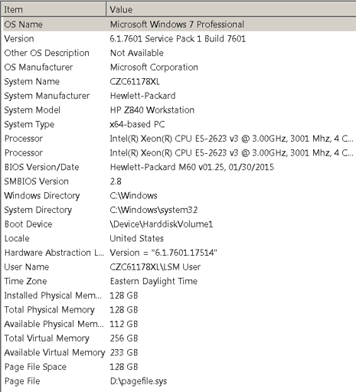

#### Please note that the Sikulix code will need to be edited to recognize the unique windows environment, application icons, and application graphic user interfaces for each PC. Please refer to “Instruction of Sikulix code.html” file.

### The applications

* + 1. ZEN Black: ZEISS application to operate the confocal microscope and two photon laser source hardware and perform image acquisition and UV targeting.
    2. imgeJ/Fiji: open source application to modify images and generate mask files.
    3. Spyder: Integrated development environment (IDE) for python code.
    4. Sikulix: Icon recognition and automation platform for the Windows environment
    5. Google Chrome: Web browser operating the Gmail web-portal which is used by Sikulix to send warning messages. 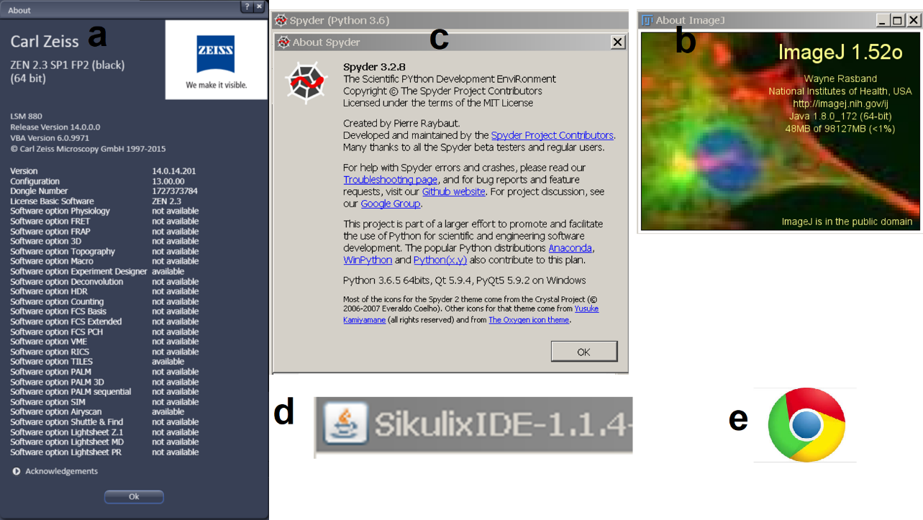

### Workflow for auto-STOMP

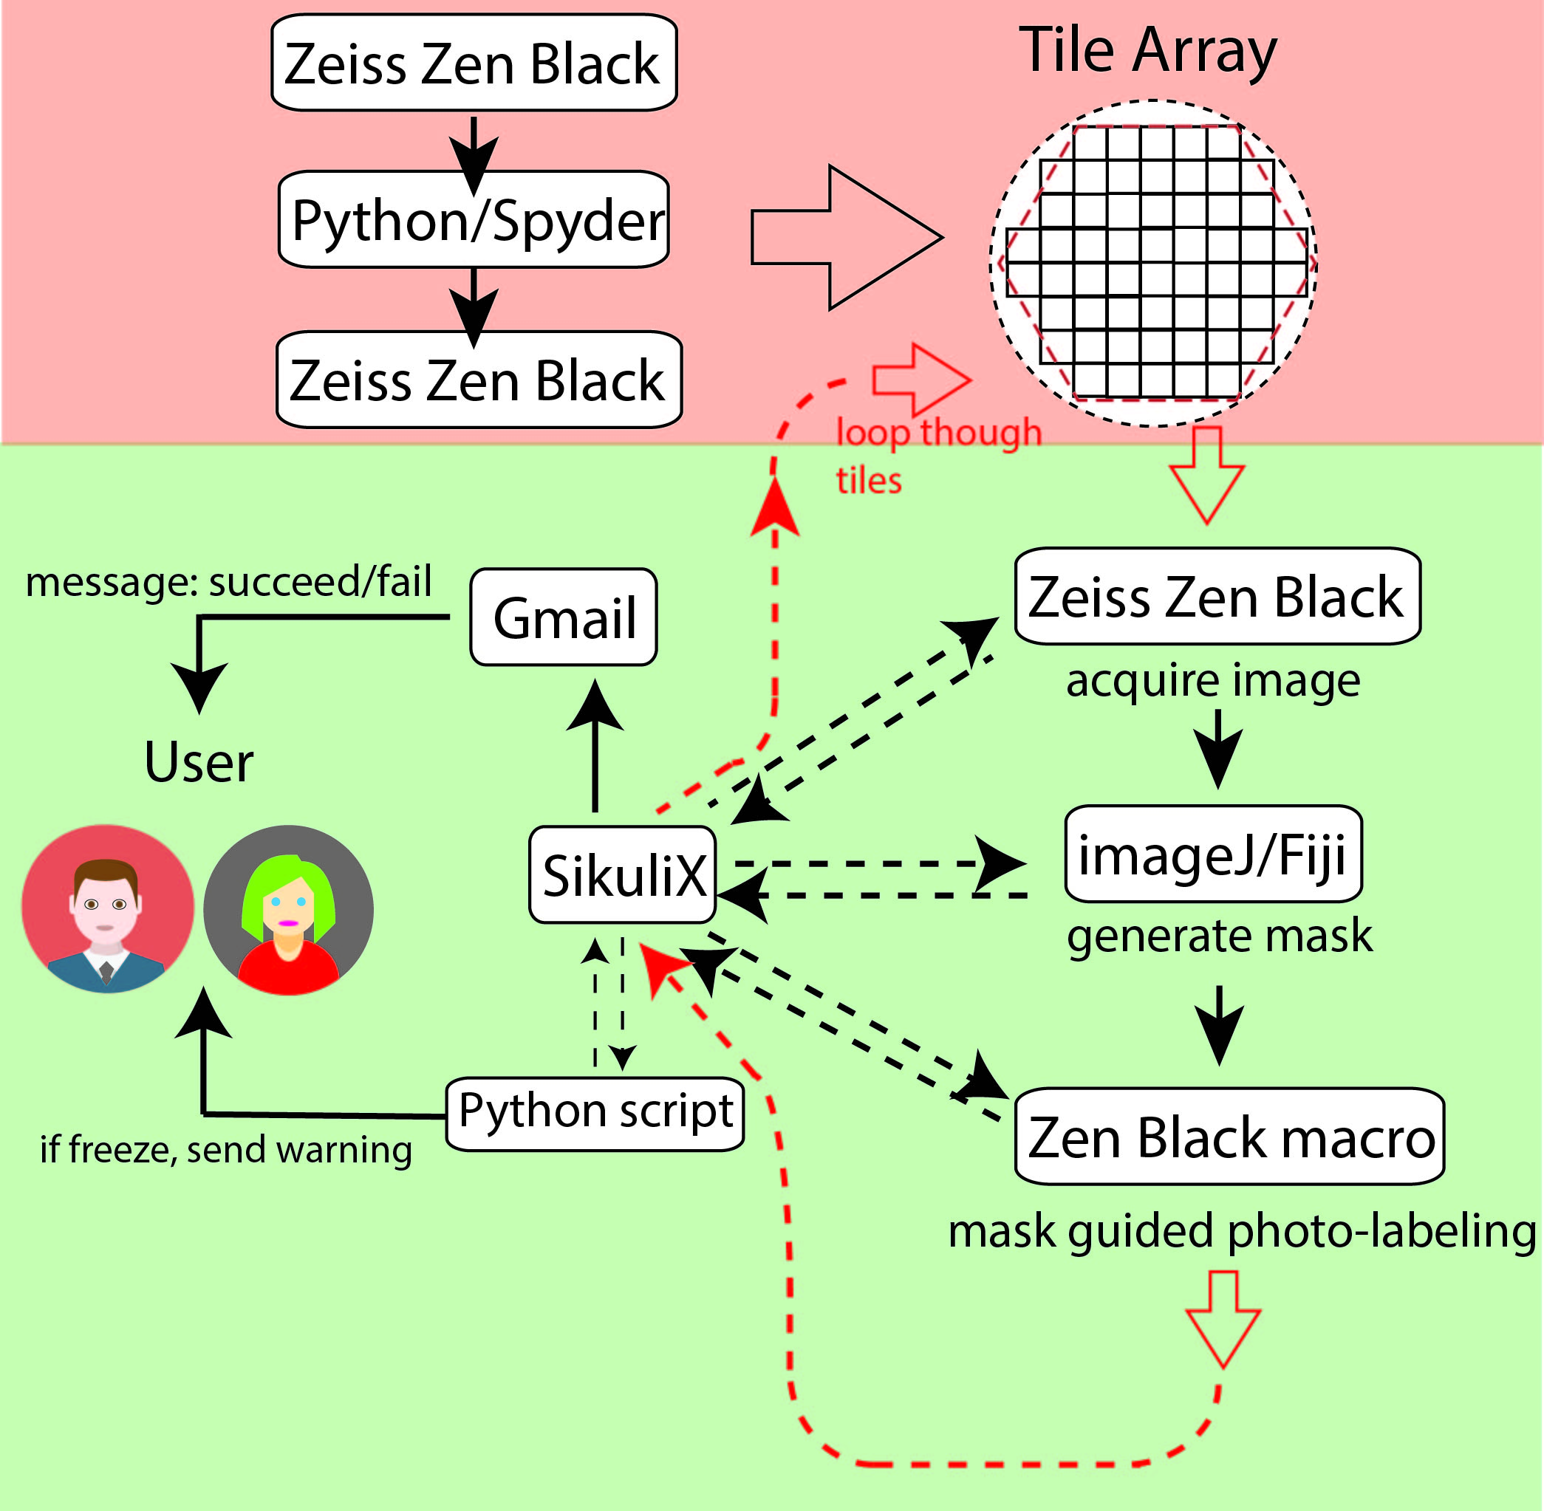

## step-by-step tutorial

### 1. Prepare samples for microscopy

### Fix cells grown on coverslips or fresh-frozen tissue sections by emersion in 100% methanol stored at -20 to -30 oC for 15 min.

### Rinse coverslips/slides with 1x PBS (room temperature) three times.

### Block the endogenous biotin in the sample with biotin block kit (#SP-2001, VectorLabs) following the manufacturer’s instruction.

### Label the structure of interest using stains or antibodies with fluorophores excited by visible wave length light (e.g. 488nm or 594nm light excitation).

### Mount the slides in 1μM biotin-benzophenone in a solution of 50:50 DMSO: water (12 μL is sufficient volume for a 12mm coverslip). It is recommended to mount and seal the slide in the cold room. It is common to see bubbles forming inside when mounting is done at room temperature which could be ascribed to the rapid evaporation of 50:50 DMSO:water. Store in the dark at room temperature.

#### note: the biotin-benzophenone is photo-activated by UV wavelengths (two-photon excitation at 720 nm) so shielding the sample from daylight is essential.

### 2. Photo-labeling on the microscope

### 2.1 Prepare the LSM for imaging and load the slide on microscope stage

* The specifications of our microscope:

|  |  |
| --- | --- |
| Models | Zeiss LSM 880 |
| Detectors | PMT and Airyscan (LSM 880) |
| Two-photon Laser | 720-930 nm (Coherent® Chameleon Ultra) |
| Invisible Laser | 405 nm (LSM 880) |
| Visible Laser | 458, 488, 514, 543, 594, 633 nm (LSM 880) |

* Objectives:

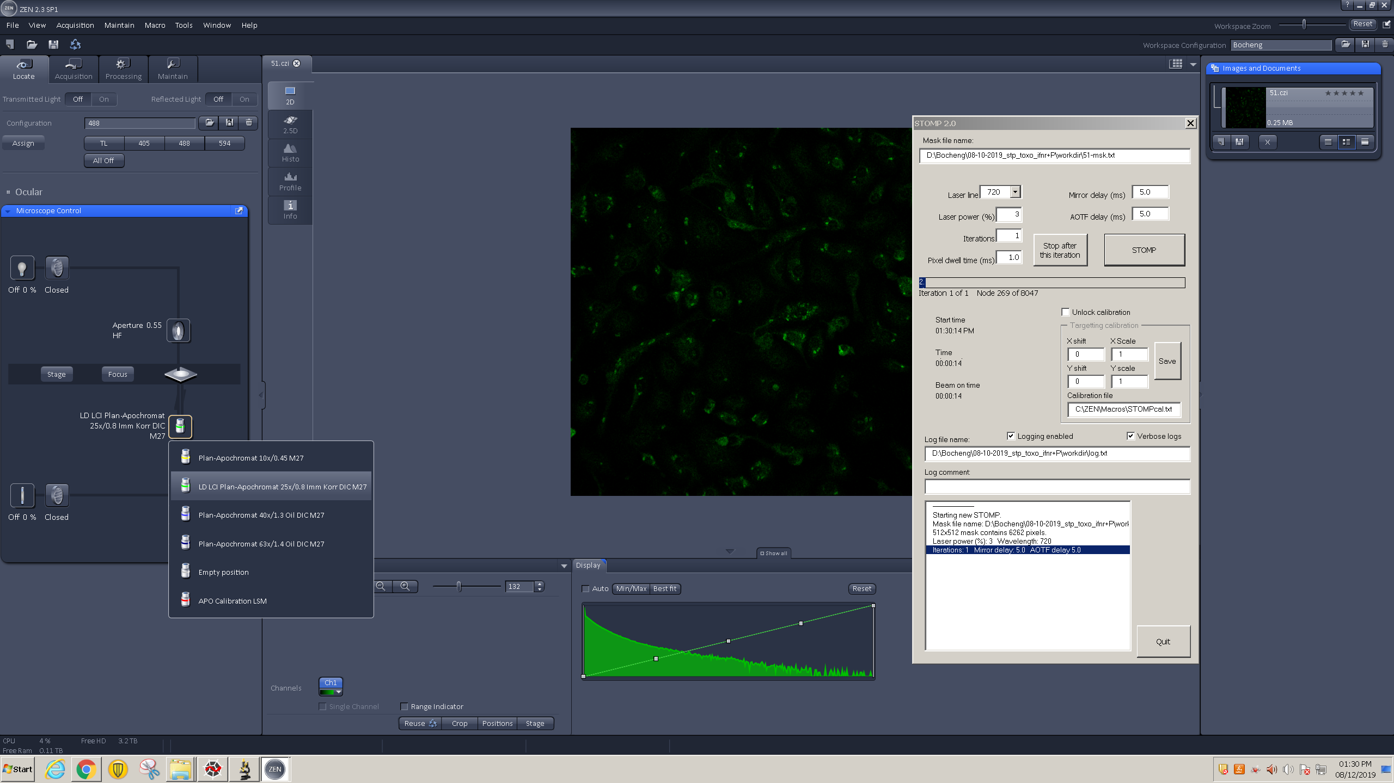

For this protocol the 25X oil immersion objective lens is used for STOMP. However, alternative 10x or 20x water/oil emersion lenses can be substituted.

### Open the applications on Windows: ZEN Black, Fiji, Spyder, Sikulix, and Chrome.

### Please refer to the following layout in Zen Black GUI.

* 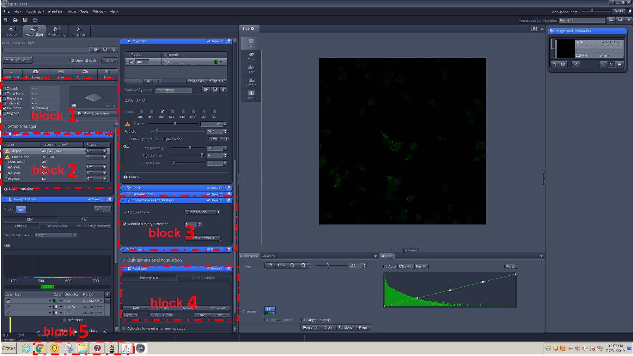

### Note: ZEN Black GUI occupies the whole screen all the time. Other applications either sit on its top temporarily or hide in the background.

### Block 1: choose a multi-dimensional experiment by checking the “Positions” box.

* 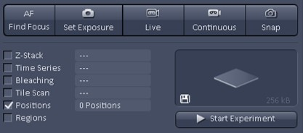

### Block 2: set up the lasers used for the experiment. These include the visible light lasers for image acquisition (here we use 488) and the multi-photon source (Chameleon) tuned to 720nm for photolabeling.

* 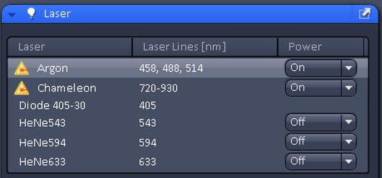

### Block 3: setup the autofocus by checking the “Autofocus every n Position” box and set the pulldown menu to 1

* 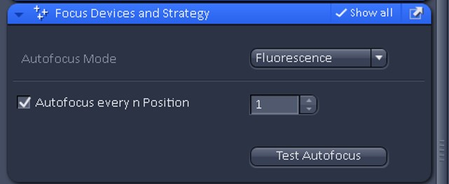

### Block 4: this panel will be used to define the boundary positions of the sample. A Python Script will load load a tile array of the imputed surface boundary positions for STOMP as described in Part 2.3.1

* + - “Add”: add a location
    - “Save…”: save a position file, “xxx.pos”
    - “Load…”: load a position file, “xxx.pos”
* 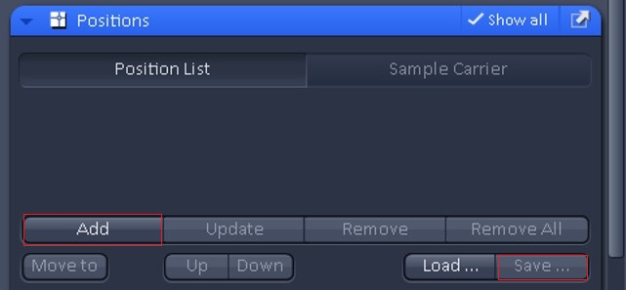

### Block 5: the Windows task bar at the bottom of the window displays active applications.

* 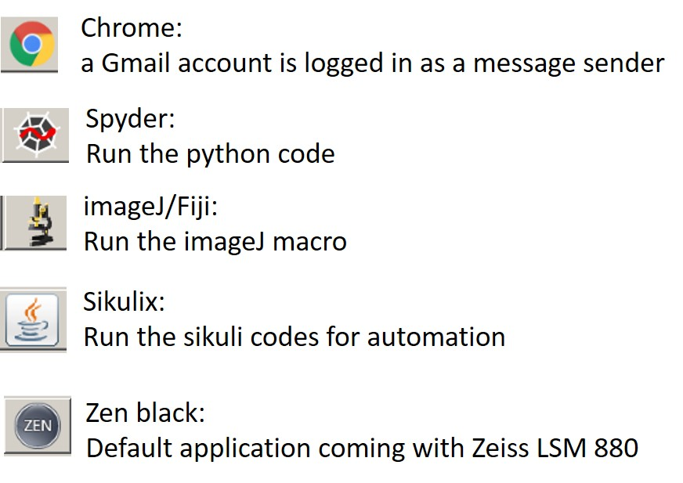

### Block 6: the drop-down menu in ZEN Black to load the STOMP macro.

* 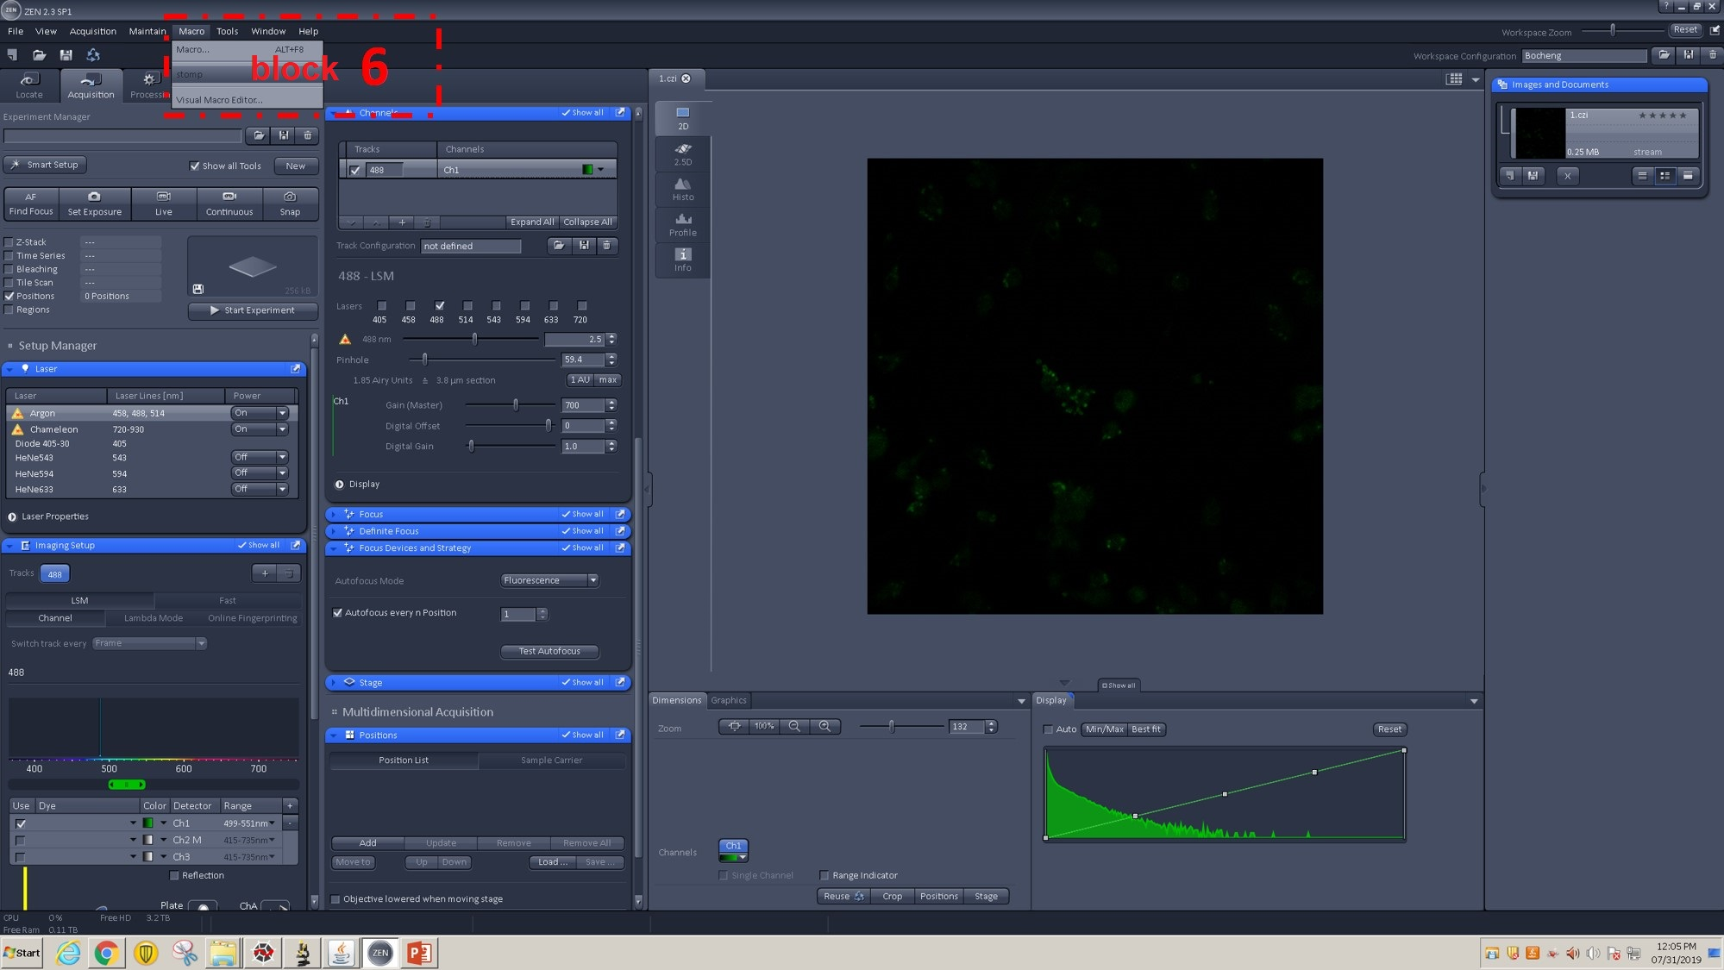

### Enlarged view of Block 6:

* + 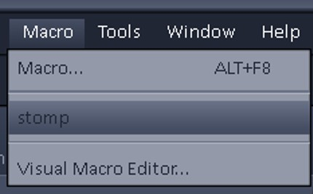

### Block 7: GUI for SikuliX and Spyder

* 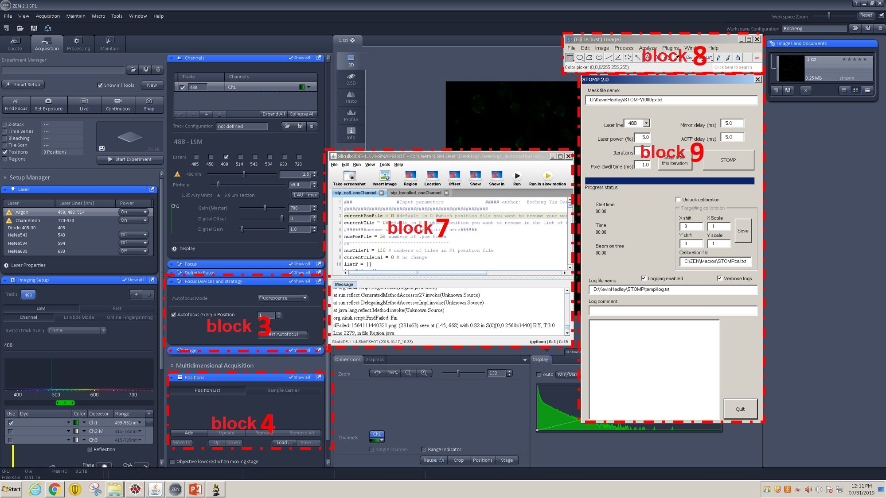

### note: only one GUI (sikuliX or Spyder) can be open in front of Zen Black at a time. Here are examples of Sikulix:

* + - 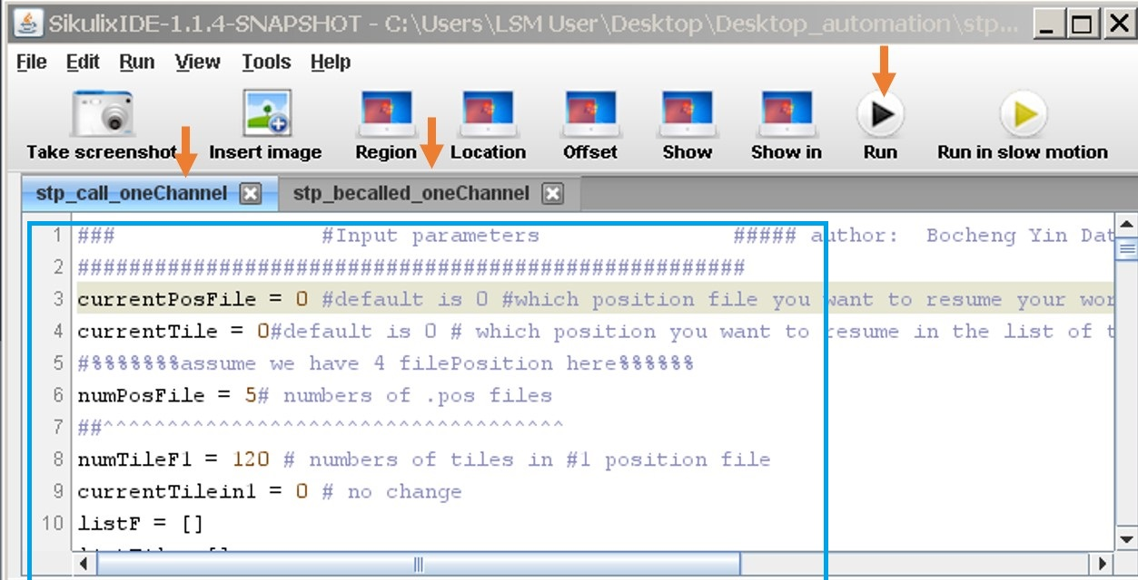

### and Spyder:

* + - 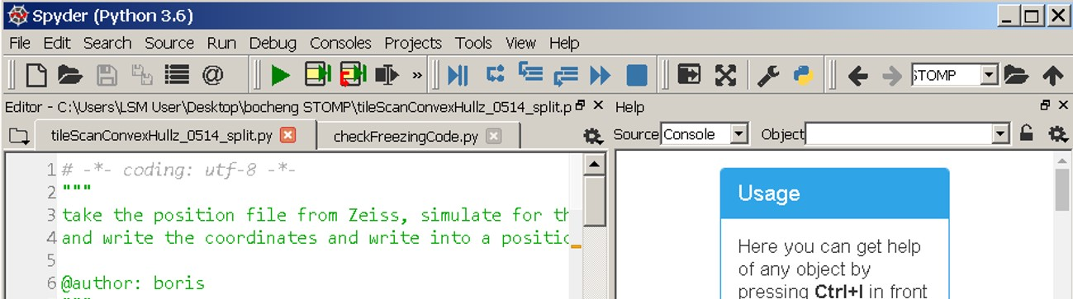

### Block 8: Fiji image thresholding and MAP file generating software.

* + 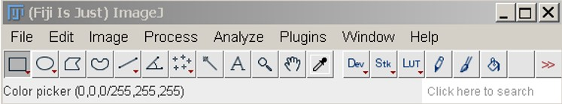

### Block 9: STOMP macro GUI in Zen Black.

* + 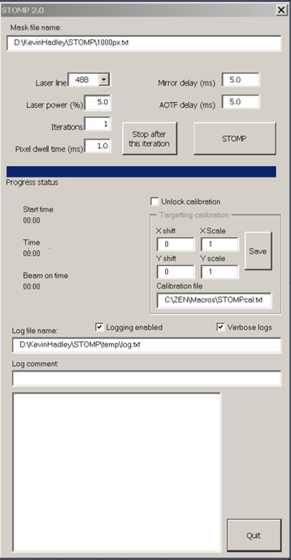

### Warning: the blocks 2,3,4 in ZEN Black must not be blocked by other windows or GUIs. Icons on these blocks are recognized by Sikulix. The SikuliX code will crash if they are obscured.

### 2.3 Setup the tile array for automation.

### Workflow:

* 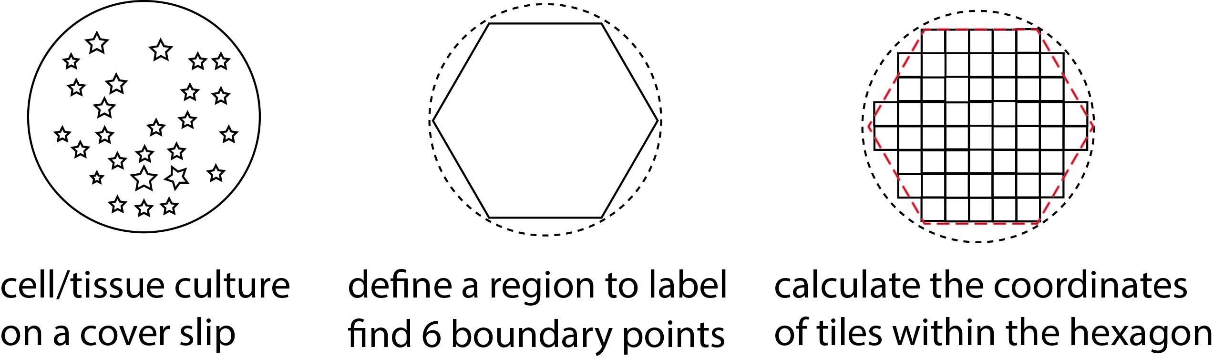

### Please refer to the video for detailed workflow:

#### <https://youtu.be/NOGta5AVfo8>

### 2.3.1 Define the boundary points along the coverslip.

### Using manual focus identify the sample edge of the coverslip.

### Using block 4 the ‘Positions’ panel click "Add” to add define the coordinates of the first boundary point.

### Repeat this process (6-8 boundary point coordinates are sufficient) to roughly define the edge of the sample.

### Using Block 4 the ‘Positions’ panel, click "SAVE” to save the boundary position list as a .pos file (i.e. “07-31-2019.pos”) in the folder “C:/ZEN/”.

* 

### 2.3.2. Create the tile array within the boundary points.

### 2.3.2.1. Using Block 7 “Spyder GUI” load the Python script “tileScanConvexHullz_split.py”

* + - 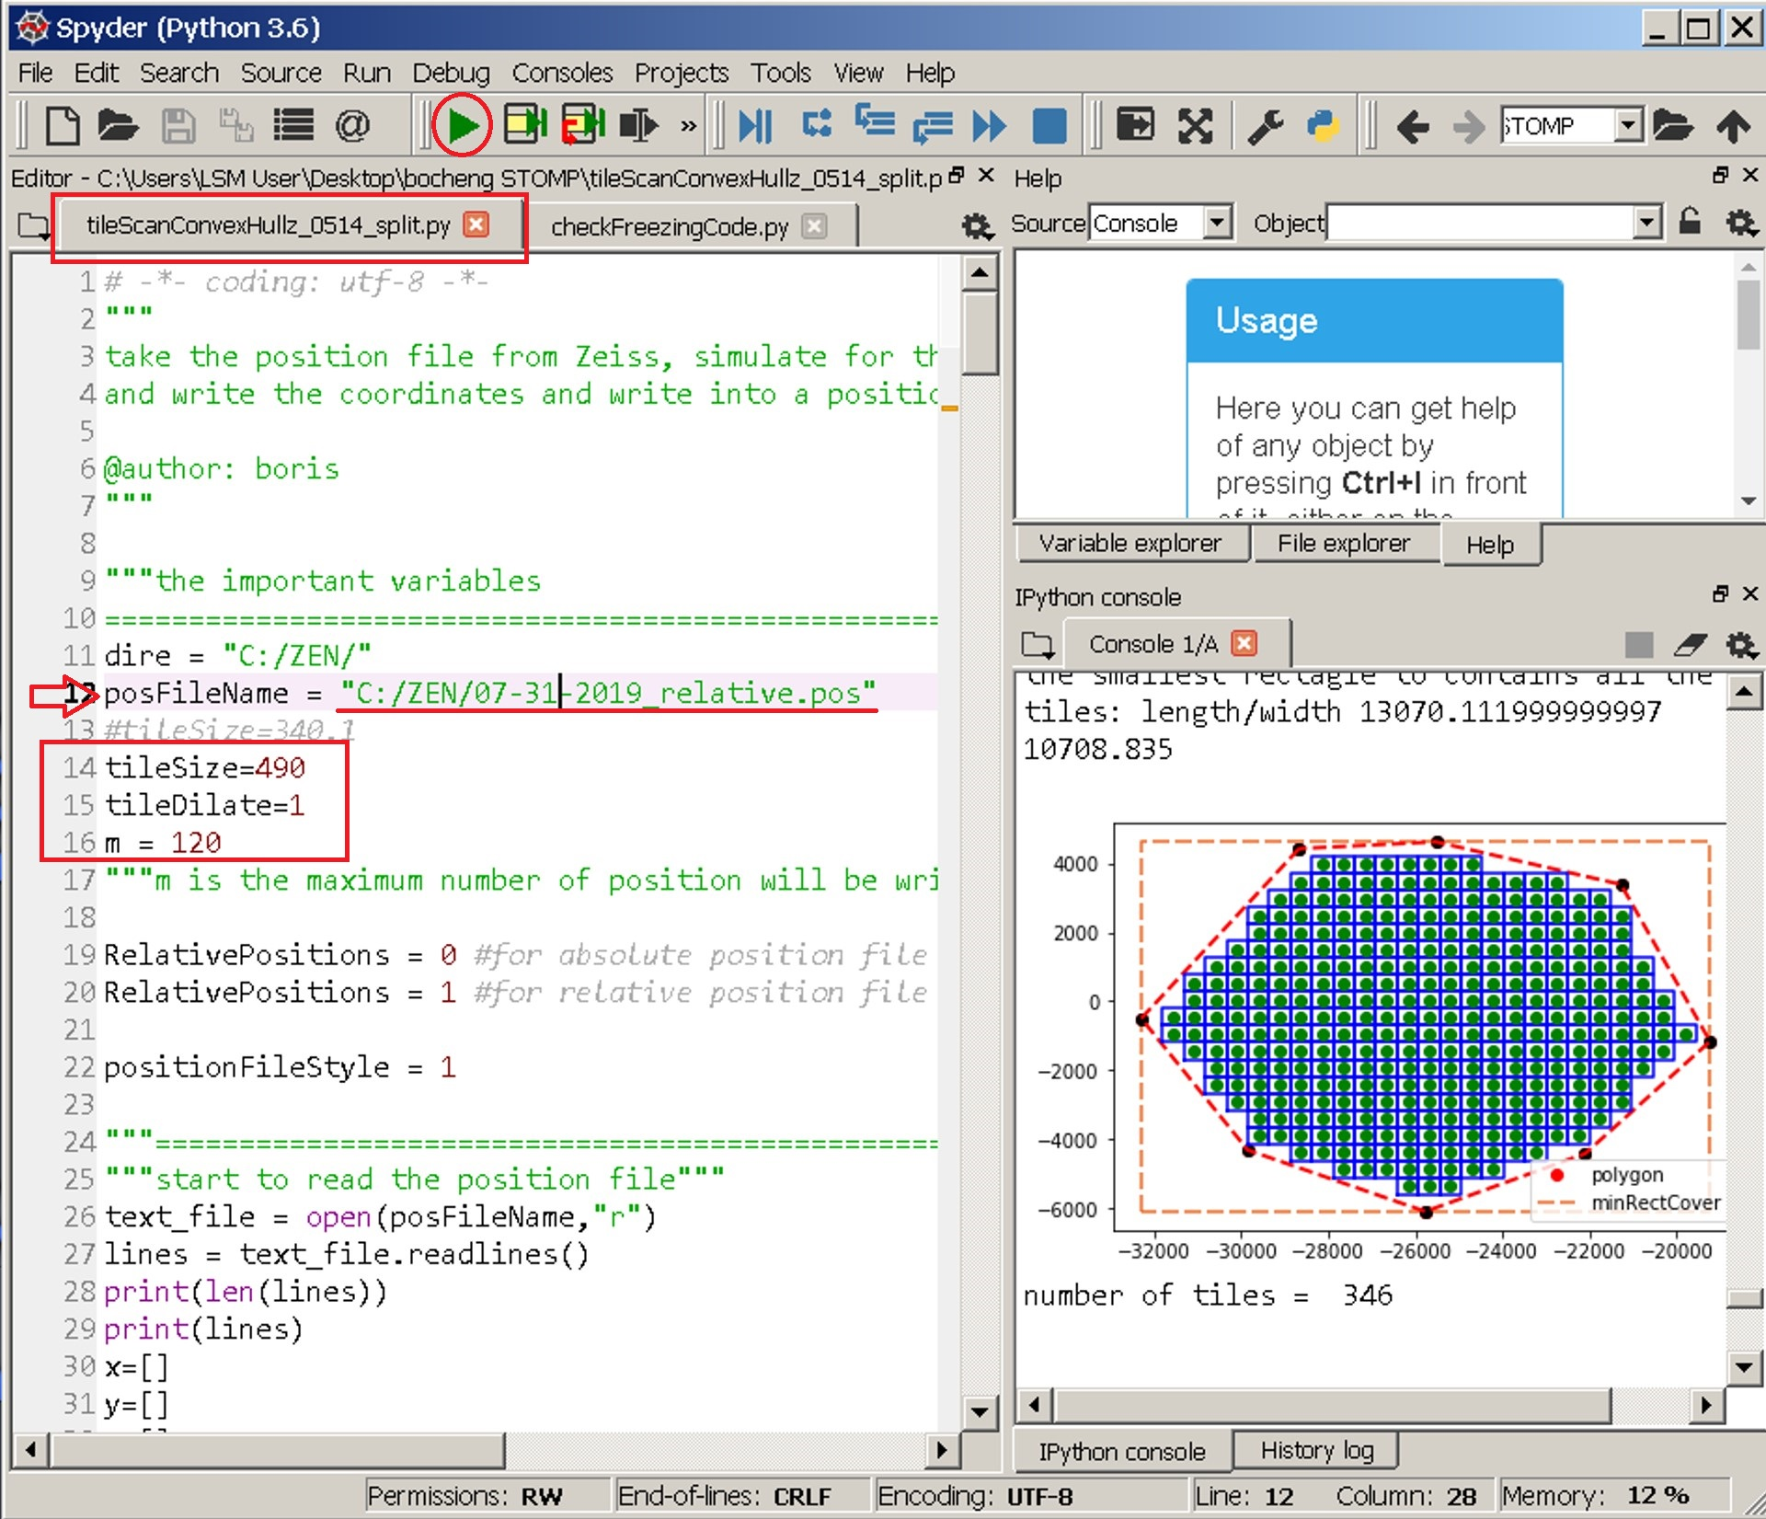

### 2.3.2.2. In Block 7 the ‘Spyder GUI”, edit the script as follows:

### Line 12: enter the path of the boundary list file that was just pre-saved “07-31-2019.pos” in the folder “C:/ZEN/”.

### Line 14: enter value of the tile size. For example, for the 25x lens on our LSM 880, the size of each field is 340.1 μm. Enter 340.1 here to generate tiles paved across the pre-defined sample surface without a gap in between. If gaps between the tiles are needed, a number larger than 340.1 can be entered here.

Note: The size of each field can be found in the “Acquisition Mode” panel of Zen Black.

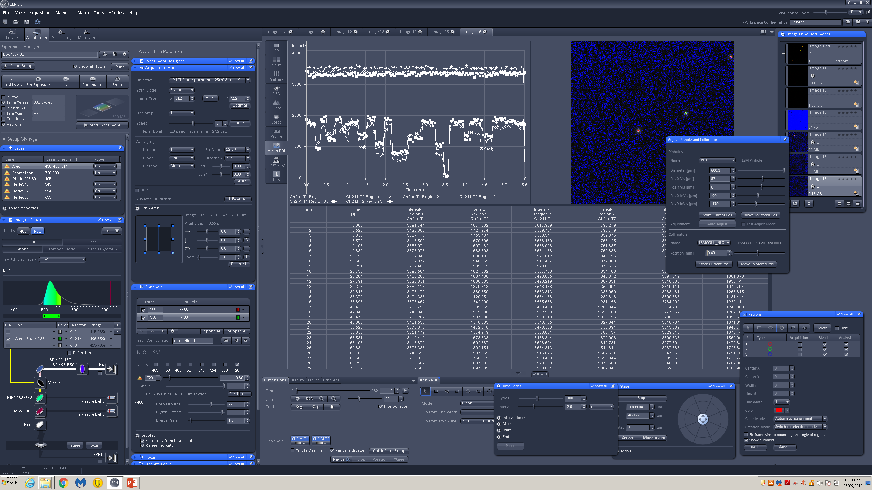

### Line 16: defines the maximum numbers of tiles that can be written into the position file.

### 2.3.2.3. Run the script “tileScanConvexHullz_split.py” after the parameters are entered.

### WARNING: ZEN Black may freeze when a position file contains more than 120 positions. To avoid this issue , the code automatically splits the tile arrays greater than 120 positions into multiple position files with a maximum of 120 positions in each one.

### For example, if a tile array contains 479 files 4 position files will be generated. They are “tilePos-1.pos”, “tilePos-2.pos”, “tilePos-3.pos”, and “tilePos-4.pos” in the folder “C:/ZEN/”.

### Note: The information for the position files is listed in the panel “IPython console” in Block 7 “Spyder GUI”

### 2.3.3. Setup the imaging parameters.

### 2.3.3.1. In Block 4: the “Positions” panel load the positions file:

### Note: You may manually load the position file (i.e. “tilePos-1.pos”) or SikuliX script can automatically load the four pre-generated position files, “tilePos-n.pos, n= 1,2,3,4) in a sequence.

* + - 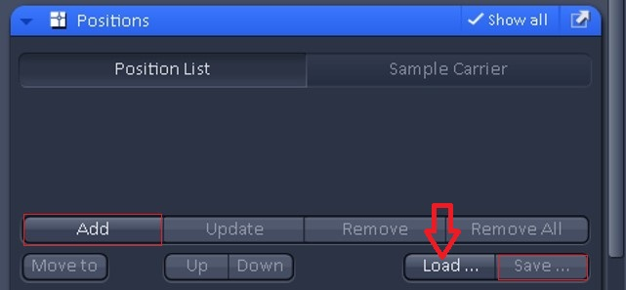

### 2.3.3.2. move to a chosen tile (i.e. tile 6).

### **2.3.3.3.** Manually adjust the laser power, receiver gain and focus to establish an image with optimal signal to noise to image your structures of interest.

### Note: Examine at least 2 additional tiles to ensure the imaging parameters are ideal across the sample. Then the imaging parameters are settled.

### 2.3.3.4. Acquire images with 512 x 512 pixel-by-pixel format, save it as “image6.czi” in the folder “D:/STOMP_0731/”.

Note: You can make any directory to place the images. Here in this tutorial, “D:/STOMP_0731/” is used for demonstration.

### Warning: close all active images in Zen Black after the test. These images if open will interrupt the automation run of SikuliX scripts.

### 2.3.4. Mask generation in imageJ/Fiji

### 2.3.4.1. In block 8 “Fiji” install the Fiji macro used for mask generation

#### “self.ijm” and “donut.ijm” are provided as examples

* + - * 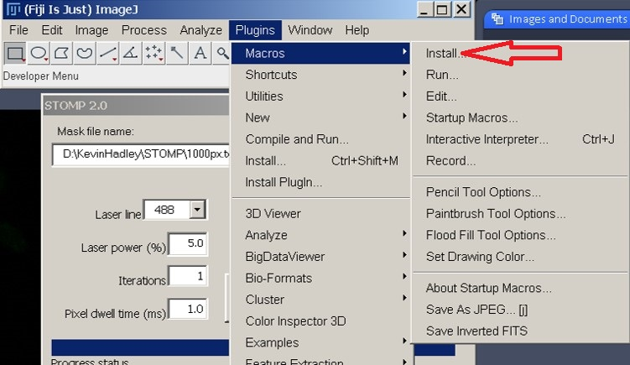

### Here, the GUIs are displayed after “donut.ijm” is loaded.

### Refer to *the instruction of imagej_Fiji macro* for the maintenance and reuse of the macro.

* + - 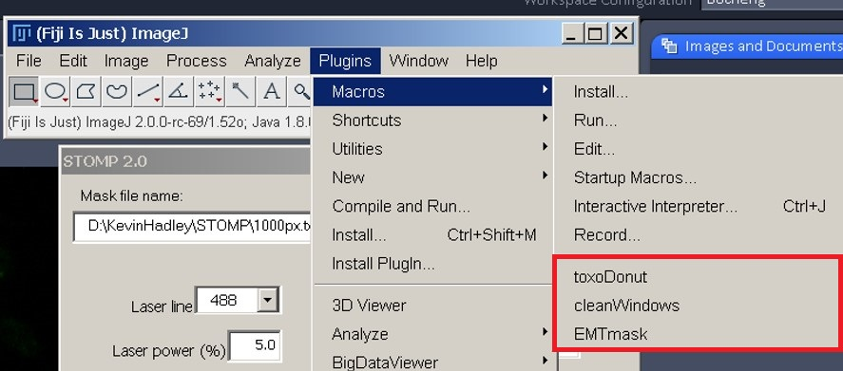

### 2.3.4.2. In Fiji, open “image6.czi” acquired in step 2.3.3, then click “toxoDonut” in the macro panel (red line box).

#### Check whether the image threshold is set properly with the auto-thresholding function by comparing the original image “image6.czi” and “image6-binary.tif” in the folder “D:/STOMP_0731/”. If this does not look correct, choose the correct threshold value and set it in the macro.

#### Check the mask image ”image6-msk.tif” generated in the folder “D:/STOMP_0731/.” This should show a 1 μm donut shaped ring around the original structures of interest in “image6.czi”

#### Warning: after the test, close all active images and windows except the Fiji GUI by calling the macro, *clearWindows*. Otherwise these will obscure SikuiliX icon recognition and SikuliX will fail.

### 2.4. Automation using Sikulix.

### 2.4.1. Set up the tile array from step 2.3 using block 7 “SikuliX GUI” by calling the script “stp_call_oneChannel.sikuli”

### Warning: If this is your first time to run Sikulix, please disable the sleep mode in your Windows system. The sleep mode could stop Sikulix running.

### Power Options control panel in Windows 7: Start button > Control Panel > Hardware and Sound > Power Options

* + - In the power options control panel, choose “Never Sleep”.

### Enter the values obtained in step 2.3.2 into the script.

To identify each tile (field of view) the Sikulix code follows the syntax, the index of the Nth tile is N – 1, starting at the value of 0. So the first tile in the array will have the index of 0 (1-1=0), the 100th tile will have the index of 99 (100-1=99). For example, if four position files are generated at step 2.3.2 that contain 120, 120, 120, 119 tiles, respectively, the following values will be entered:

|  |  |  |
| --- | --- | --- |
| Variable | Value | description |
| currentPosFile | 0 | Start from position file 1, “tilePos-1.pos” |
| currentTile | 0 | Start from tile 1 |
| numTileF1 | 120 | 120 tiles contained in “tilePos-1.pos” |
| numTileF2 | 120 | 120 tiles contained in “tilePos-2.pos” |
| numTileF3 | 120 | 120 tiles contained in “tilePos-3.pos” |
| numTileF4 | 119 | 119 tiles contained in “tilePos-4.pos” |
| hostPath | “D:/STOMP_0731/” | The working directory where images are stored |

### Line 101: enter your gmail address to receive automatic user notifications about the status of the Sikulix Code while it is running or if it fails. Example:



## please refer to *instruction_of_Sikulix_code.html*.

* + 

### 2.4.2. Run the sentinel script “checkFreezingCode.py” in block 7 “Spyder GUI”

#### This script will monitor Sikulix and report a frozen status if an error occurs.

#### Enter the sender (line 15), the password for the sender (line 18) and the receiver (line 16).



#### Warning: Minimize the window of Spyder before the Sikulix run starts.

* 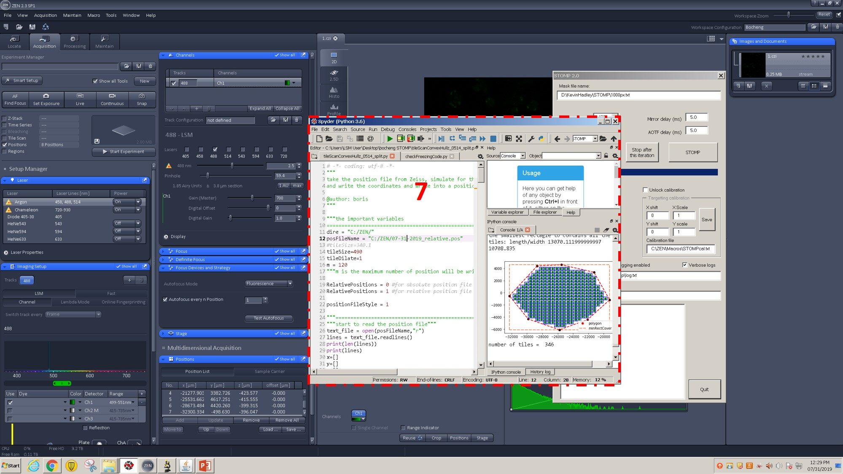

#### The tabs of the python scripts in Block 7 “Spyder GUI” are shown as below:

* + 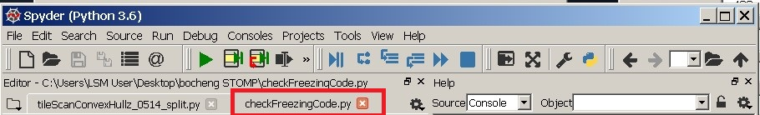
  + Note: “checkFreezingCode” monitors the activity status of Sikulix every 30 minutes.

### 2.4.3. Load block 9 “STOMP macro” if it is not open yet.

* 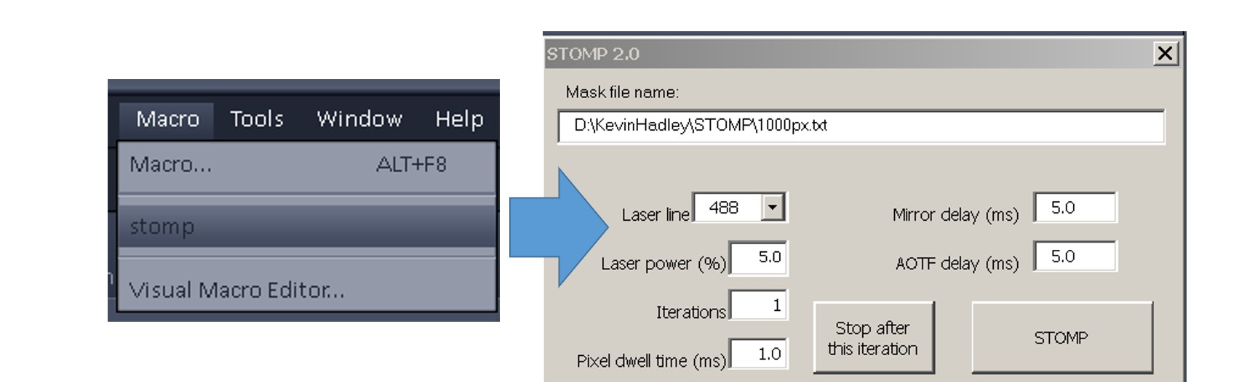

### Note: The parameters in the STOMP macro should be preset as shown. There is no need to modify them now. Sikulix codes enter the correct values while the program is running. The power parameters typically for STOMP with our 25X objective lens (N.A. = 0.8) are as below:

### However, these values can be varied based on the objective and sample in use.

|  |  |
| --- | --- |
| Laser Line (nm) | 720 |
| Laser power (%) | 3.0 |
| Iterations | 1 |
| Pixel dwell time (ms) | 1.0 |

### 2.4.4. Open the Gmail web-portal in Chrome.

### Warning: Minimize Chrome GUI before running SikuliX.

### For example, we use a group Gmail account “anthonyewald2019@gmail.com” as the sender. This account should be logged in before running Sikulix.

### 2.5. Run the SikuliX code in block 7 “Sikuli X.”

### please refer to this video of automation

#### <https://youtu.be/mKX-ndwCNQQ>

* + 

### 2.5.1. once the run starts, the Sikulix window will disappear, so does its icon at the task bar at the bottom of Windows desktop:

* + 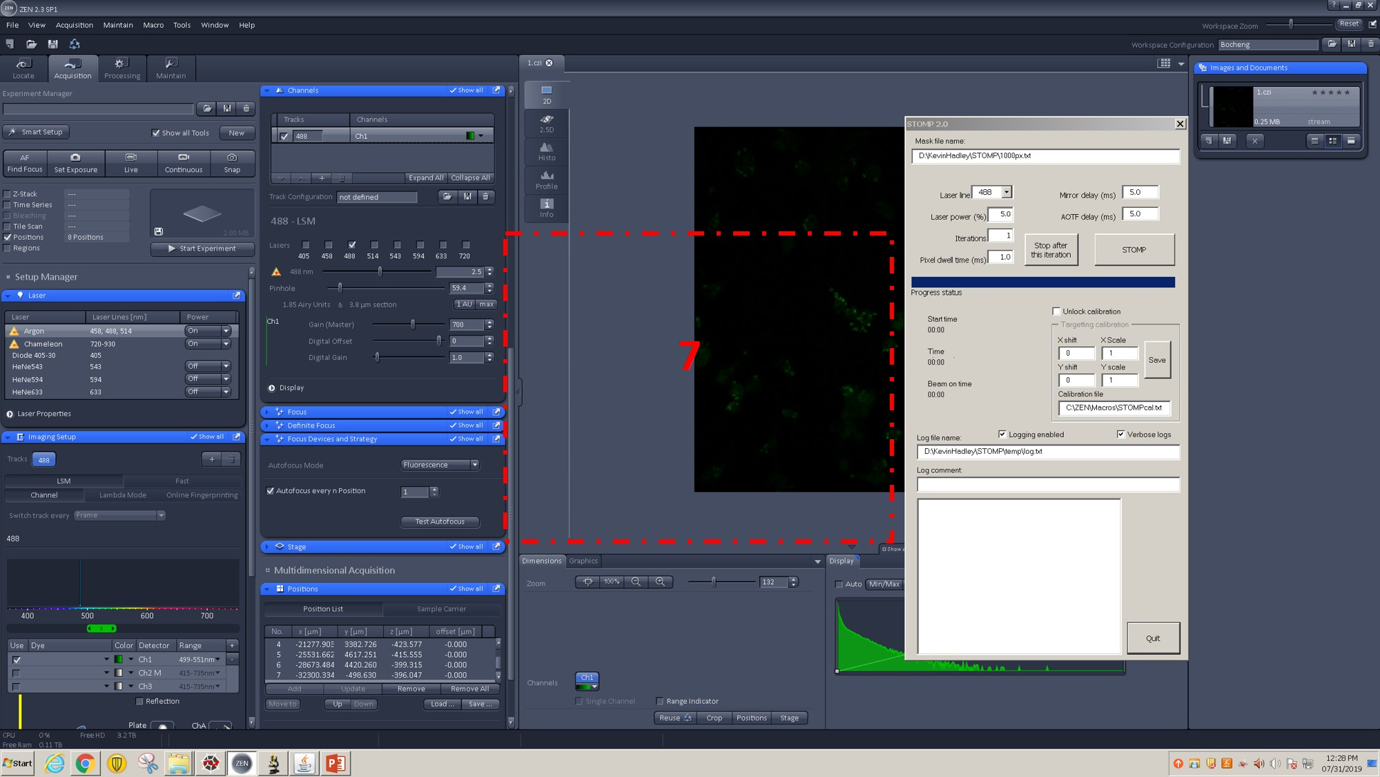

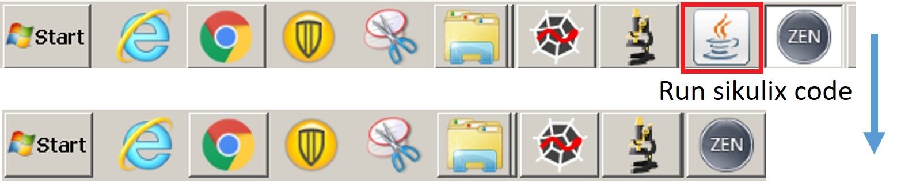Note: the Sikulix IDE will re-appear when it is interrupted and forced to quit.

2.5.2. Close the PC display. The display doesn’t need to be on all the time

2.5.3. Close the halogen lamp. The halogen lamp has limited bulb lifetime, and doesn’t need to be ON during Sikulix run. But you must turn the lamp back on and restart the Zen Black before starting STOMPing on a new slide.

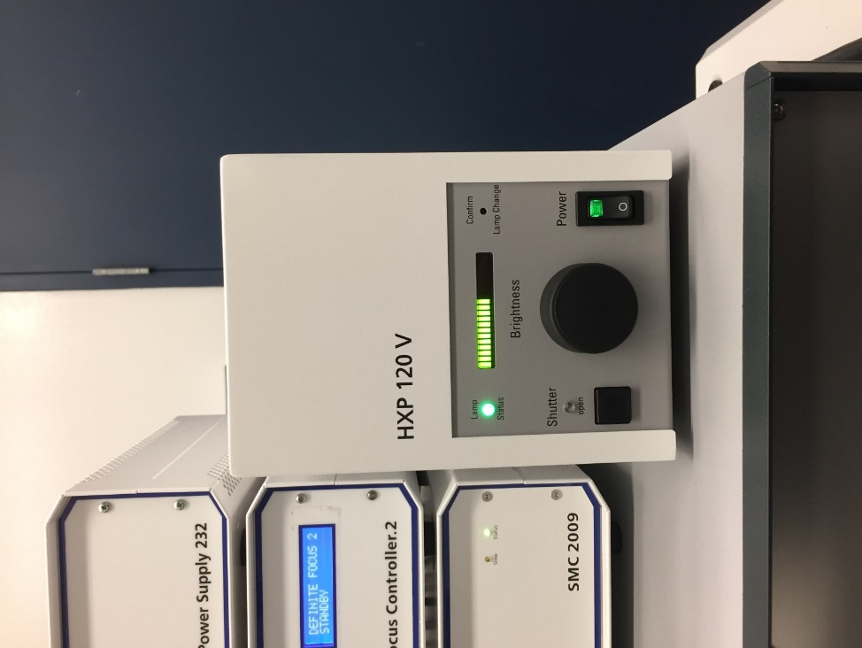

### Trouble shooting:

### As noted in “instruction_of_Sikulix_code.html” we have outlined solutions for each error code that has been encountered to date. Although it is possible that other errors may occur.

### If SikuliX is forced to stop, record the error message. If the solution is not simply a masked Icon, see if the error is reproducible and consult the trouble shooting instruction in “instruction_of_Sikulix_code.html” to amend the SikuliX script.

### Once the code has been adjusted return to step 2.3 to 2.4 to ensure the windows are ready for SikuliX automation.

### Identify the tile where the automation should resume in “stp_call_oneChannel.Sikulix”.

### Note: the SikuliX code follows a syntax that the Nth file has an index of N-1. For example, if you would like to resume STOMP from position file #2 and tile position #51, enter 1 and 50, respectively for position file and tile position (as indicated below) in the SikuliX code.

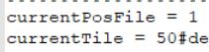

### 3. Count the total number of pixels that were exposed to UV light to estimate the amount of tagged proteins.

### 3.1. In Block 7 “Spyder” run the python code “TotalPixels_allLogs.py”.

### line 15: enter the path of the parent folder generated at step 2.4.1.

* + 

### The script will iterate through all its subfolder and collect and summarize the total pixels.

### Note: the images and log files are organized into the folders by the order of the position files generated at the step 2.3.2.

* + 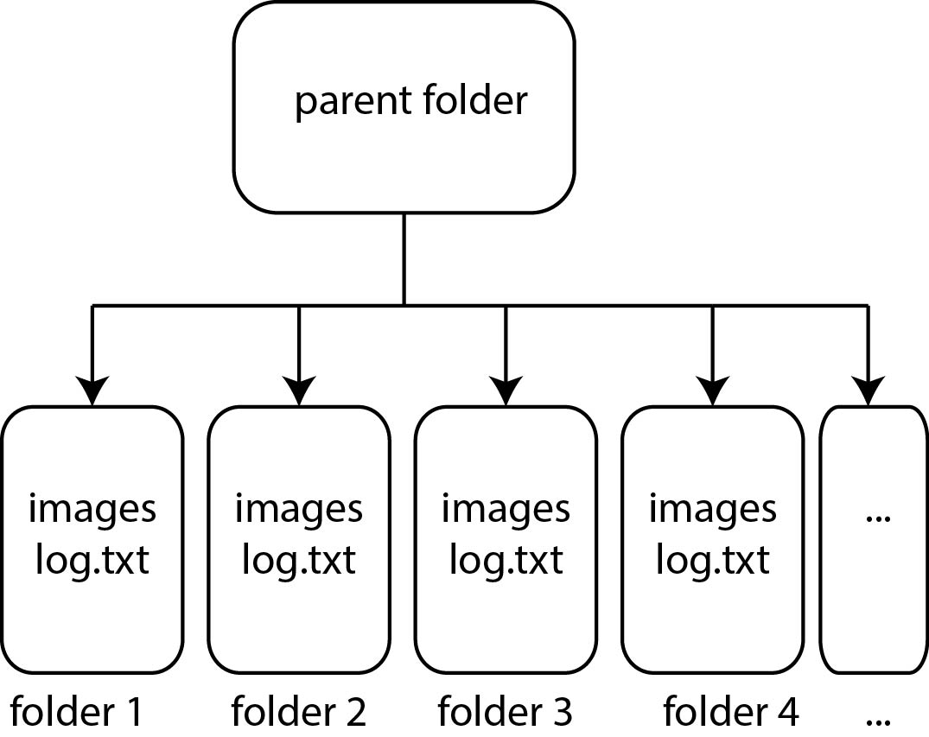

### Note: Typically, labeling 4 - 5 million pixels with mask resolution: 512x512 pixel-by-pixel under 25x lens should biotinylate sufficient proteins for one Mass Spec sample submission. Approximately four days per sample on the microscope is required to biotinylate adequate proteins for each sample.

### 4. Preparing the samples for storage and streptavidin purification.

### Note: Several coverslips are usually necessary to tag sufficient protein for mass spec. To avoid off-target biotinylation each coverslip is washed and stored immediately after UV-cross linking is complete.

### 4.1 Once UV-cross linking is complete, unload the slide from the microscope.

### Remove the immersion oil with a cotton swab.

### Then soak the slide in the de-ionized water for at least 30 minutes at RT, gently shaking and in the dark.

### 4.2 Gently peel off the nail polish seal securing the coverslip to the slide, and transfer the coverslip to a parafilm with the sample side facing up.

### 4.3 Wash the un-crosslinked BP-biotin affinity tag off the coverslip.

### Gently add 1 mL 50:50 DMSO:water to the coverslip, and aspirate the liquid after 5 min. Repeat 3 times.

### Gently add 1 mL water to the coverslip, and aspirate the liquid after 5 min. Repeat 3 times.

### Using tweezers, lift and the coverslip and dab on a Kim wipe to remove excess water. This limits ice crystal formation during storage.

### 4.4 Store the coverslip in -20 to -30 C freezer until all coverslips are UV cross-linked and you are ready to prepare lysate for mass spectrometry analysis.